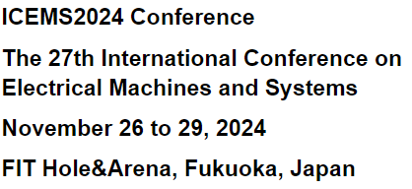

**ICEMS-Fukuoka 2024 Corporate Exhibit Application**

**Application deadline: September 30, 2024**

To **ICEMS-Fukuoka 2024 Secretariat** (E-mail: secretariat@icems2024.com)

I agree with the purpose of this conference and hereby apply for the corporate exhibition.

|  |  |  |
| --- | --- | --- |
| Application date | |  |
| Company name | | *Please provide the official company name as it will appear on the company name plate. The typeface will be Arial. |
| Number of booths to use | | ￥150,000 (including 10% consumption tax) x [number of booth]  ＝ \ [total amount of payment] |
| Expected due date *Payment should be completed by October 31, 2024. | |  |
| Exhibit details (planned) | |  |
| Contact details | Company address |  |
| Section |  |
| Name |  |
| Phone |  |
| E-mail |  |
| Remarks | |  |

**Inquiries**

ICEMS-Fukuoka 2024 Secretariat

(c/o E.C. Inc.)

Slack Shibuya 1101, Sakuragaoka-cho 31-14, Shibuya-ku, Tokyo, 150-0031

Attn. Asami Hoshi

E-mail: [secretariat@icems2024.com](mailto:secretariat@icems2024.com)