Abstract--Basic guidelines for the preparation of a technical paper for ICEMS2024 are presented. This document is itself an example of the desired layout (inclusive of this abstract) and can be used as a template if you are using Microsoft Word97 or later. The abstract is limited to 150 words and cannot contain equations, figures, tables, or references. It should concisely state what was done, how it was done, principal results, and their significance.
Preparation of a Technical Paper for
ICEMS 2024 Proceedings

Index Terms— The authors shall provide up to 4 keywords or phrases (in alphabetical order and separated by commas) to help identify the major topics of the paper.
Author Name A*, Author Name B**, and Author Name C*
* Department, Organization, Address, Country
** Department, Organization, Address, Country

Introduction
This document contains information regarding desktop publishing format, type sizes, and typefaces. Style rules are provided to explain how to handle equations, units, figures, tables, abbreviations, and acronyms. Sections are also devoted to acknowledgment and references.
For additional information not included in these instructions, please contact ICEMS2024 conference secretary at secretariat@icems2024.com (please replace [at] with @).

Technical Work Preparation
The total paper length must be from four (4) to eight (8) pages. No extra pages are permitted.

Format
Prepare your technical work in single-spaced, double-column format, on A4 paper sheet (210×297 mm).
Set top and bottom margins to 25 mm, and left and right margins to 20 mm. The column width has to be 82 mm; the space between two columns is 6 mm. Paragraph indentation is 4 mm. Please use left and right justification of your columns. Use one space-line between sections, and between text and tables or figures. Adjust the length of the columns on the last page.

Type Sizes and Typefaces
Please use “Times Roman” or “Times New Roman” typeface and embed all fonts (see your software’s “Help” section if you do not know how to embed fonts).
Table I provides samples of the appropriate type sizes and styles to use.

TABLE I
Times New Roman Type Sizes and Styles for ICEMS2024 Papers
Type size (pts) | Regular | Bold | Italic | Small caps
8 | Figure captions, table text, figure text, footnotes, subscripts and superscripts |  |  | Table captions
9 | Authors’ affiliation, references | Abstract, keywords, abstract title | Abstract title
10 | Body text, equations |  | Subheadings | Title of sections
11 | Authors’ names
24 | Paper title

Section Headings
A primary section heading is enumerated by a Roman numeral followed by a period and is centered above the text. A primary heading should be in small caps. The first letter of each important word is capitalized.
Do not number Appendix, Acknowledgment and References.
A secondary section heading is enumerated by a capital letter followed by a period and is flush left above the section. The first letter of each important word is capitalized and the heading is italicized.

Figures and Tables
In labeling figure axes, please use words rather than symbols. Put units in parentheses as in Fig. 1.

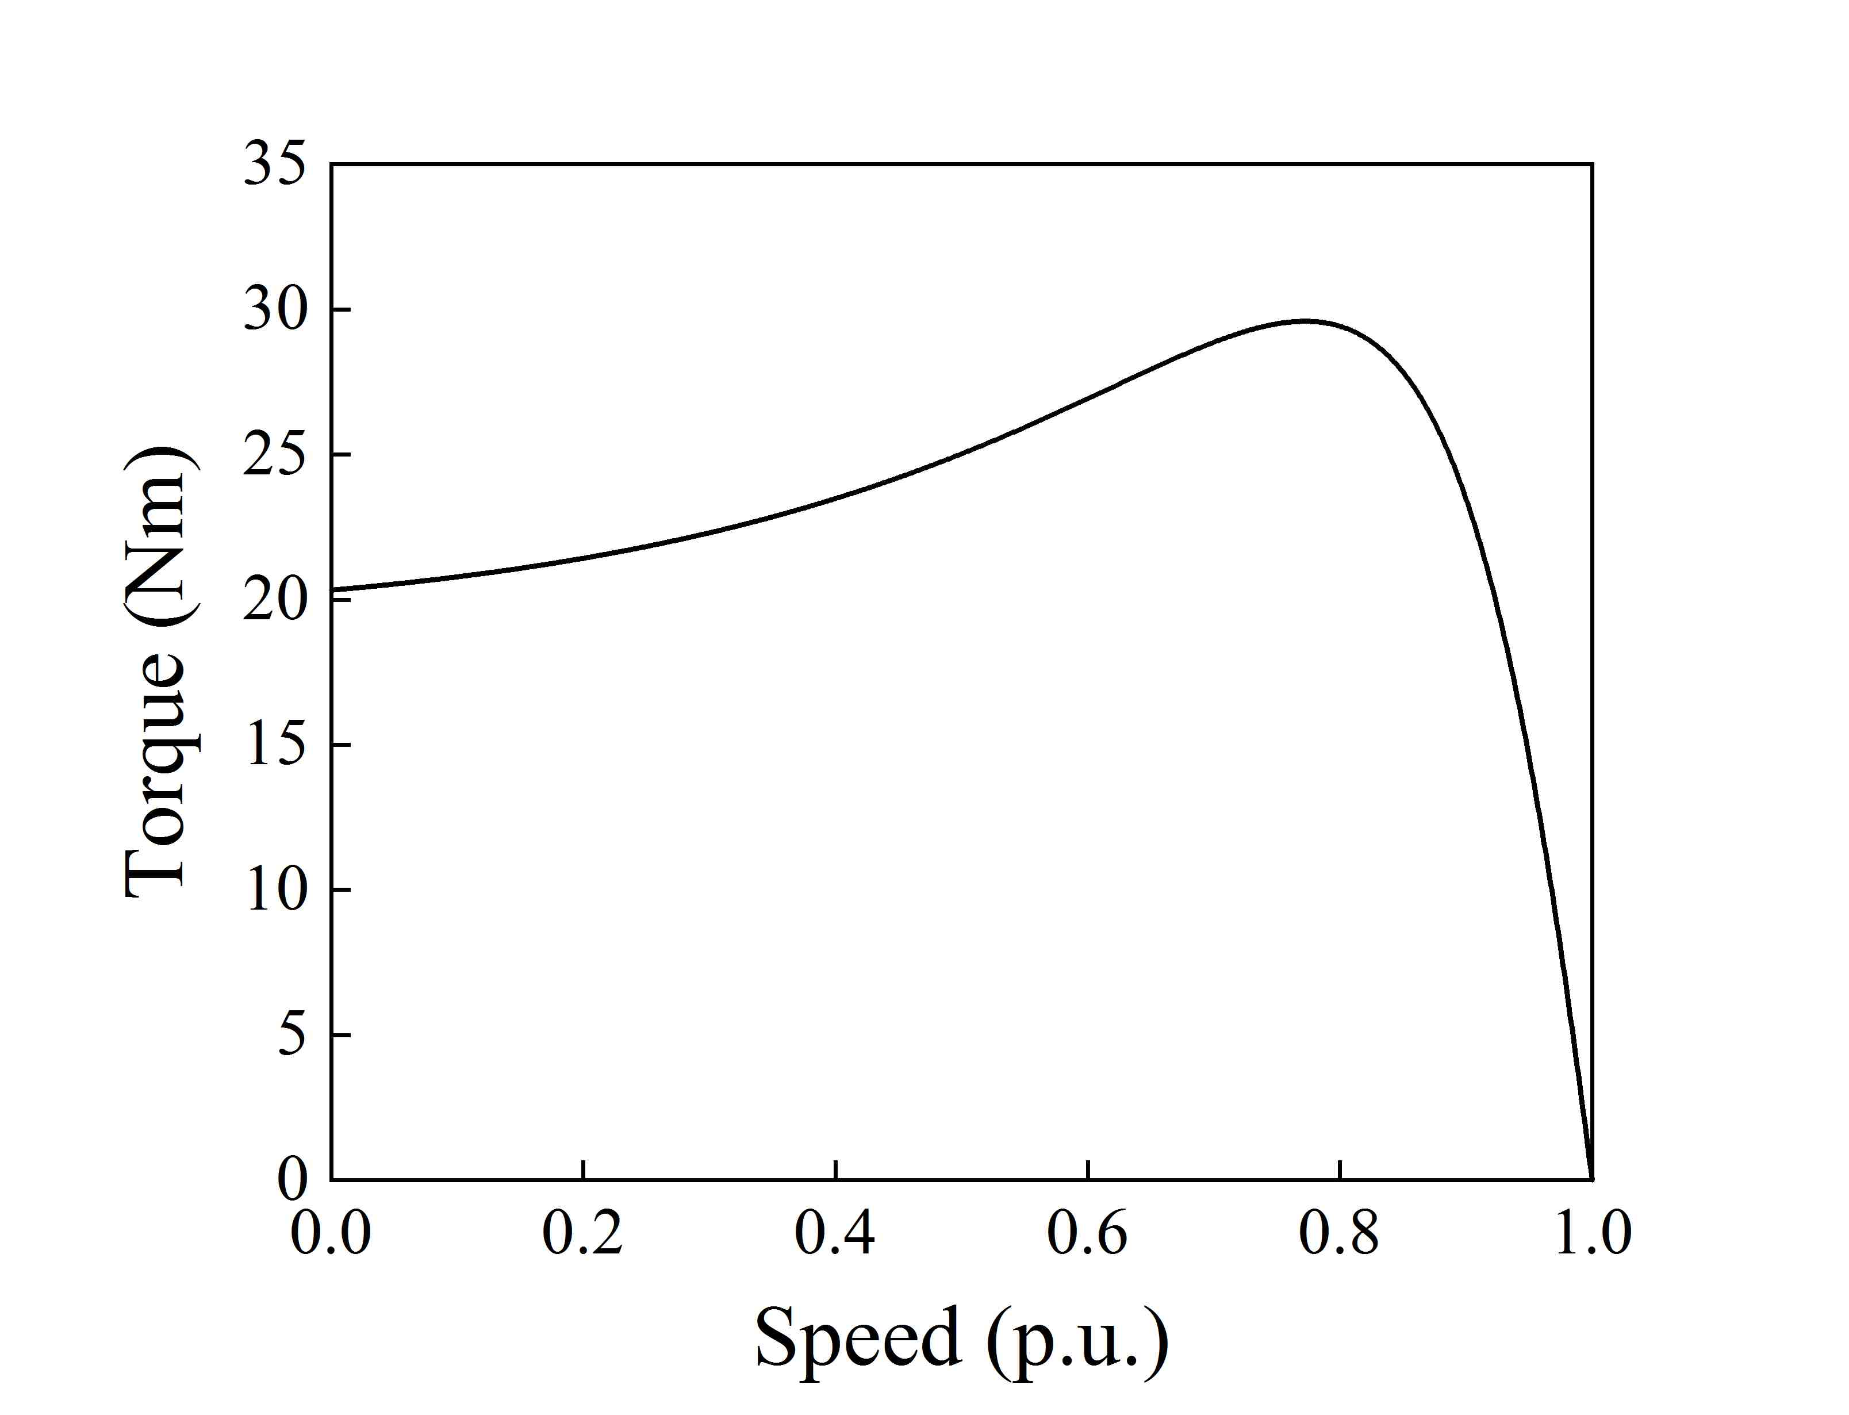
Fig. 1. Torque-speed characteristic of a three-phase induction motor.

Large figures and tables may span both columns, but may not extend into the page margins. Figure captions have to be below the figures; table captions have to be above the tables.
Do not put captions in "text boxes" linked to the figures. Do not put borders around your figures.
All figures and tables must be placed just after they are first mentioned. Digitize your tables and figures.

Numbering
Do not number pages.
Number reference citations consecutively in square brackets [1].
Number footnotes separately with superscripts. Place the actual footnote at the bottom of the column in which it is cited.
All figures and tables must be numbered consecutively. Use Arabic numerals for figures and Roman numerals for tables.

Abbreviations and Acronyms
Define less common abbreviations and acronyms the first time they are used in the text, even after they have been defined in the abstract. Do not use abbreviations in the title unless they are unavoidable.

Math and Equations
Use either the Microsoft Equation Editor or the MathType commercial add-on for MS Word for all math objects in your paper.
Number equations consecutively with numbers in parentheses flush with the right margin, as in (1).
Be sure that the symbols in your equation have been defined before the equation appears or immediately following:
, (1)
where R_{s} is the stator phase resistance.

Units
Use International System of Units (SI - MKSA) as primary units. British units could be used as secondary units in parentheses.

Conclusions
Conclusions are one of the most important parts of a paper. Please give careful consideration to this section.

Appendix
Appendixes, if needed, have to appear before the Acknowledgment.

Acknowledgment
Please place an eventual Acknowledgment here, before the References. Put sponsor acknowledgments in an unnumbered footnote on the first page.

References
List only one reference per reference number according to the following samples:

- G. Eason, B. Noble, and I.N. Sneddon, “On certain integrals of Lipschitz-Hankel type involving products of Bessel functions,” Phil. Trans. Roy. Soc. London, vol. A247, pp. 529-551, April 1955.
- J. Clerk Maxwell, A Treatise on Electricity and Magnetism, 3rd ed., vol. 2. Oxford: Clarendon, pp. 68-73, 1892.
- I. S. Jacobs and C. P. Bean, “Fine particles, thin films and exchange anisotropy,” in Magnetism, vol. III, G.T. Rado and H. Suhl, Eds. New York: Academic, pp. 271-350, 1963.
- K. Elissa, “Title of paper if known,” IEEJ Journal of Industry Applications, to be published.
- R. Nicole, “Title of paper with only first word capitalized,” J. Name Stan. Abbrev., to be published.
- Y. Yorozu, M. Hirano, K. Oka, and Y. Tagawa, “Electron spectroscopy studies on magneto-optical media and plastic substrate interface,” IEEJ Journal of Industry Applications, vol. 12, vol. 6, pp. 740-741, 2023
- M. Young, The Technical Writer’s Handbook. Mill Valley, CA: University Science, 1989.
- J. Du and H. Ohsaki, “Numerical analysis of eddy current in the EMS-maglev system.” Proc. of 6th International Conference on Electrical Machines and Systems (ICEMS 2003), Beijing (China), pp.761-764, Nov. 2003.

Submission of the Final Paper
Final papers must be submitted electronically in Adobe PDF format by no later than August 30, 2024.
All papers presented in the conference and included in the proceedings will be published in the IEEE Xplore Digital Library. Therefore, authors are requested to use the IEEE PDF eXpress to create IEEE-Xplore-compatible PDFs. The IEEE PDF eXpress is available at https://ieee-pdf-express.org/.
Detailed instructions are available on the ICEMS2024 official website at https://www.icems2024.com/.

